**Architectural views**

**Functional view:**

The functional view, is the view where the focus is on the functions of the vehicle and their dependencies on one another.

There are three elements in this diagram

1.functions

2.domains

3.dependency relations

As the functions can depend on each other and they can easily be grouped into “domains” such as Powertrain and Active Safety. The usual domains are

1. Powertrain—grouping the elements related to the powertrain of the car—engine, engine ECU, gearbox and exhaust.
2. Active Safety—grouping the elements related to safety of the car—ADAS (Advanced Driver Assistance Systems), ABS (Anti-lock Braking System) and similar.

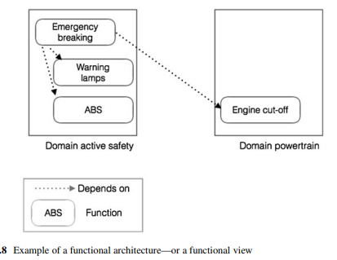

**PHYSICAL VIEW:**

This view of the architecture provides the possibility to present the topology of the electrical system of the car and provides the architects with a way to reason about the placement of the computers on the communication buses

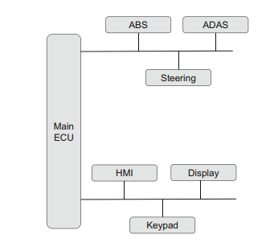

• Engine control unit (EnCU)

• Electric power steering control unit (PSCU)

• Human-machine interface (HMI)

• Powertrain control module (PCM)

• Telematic control unit (TCU)

• Transmission control unit (TCU)

• Brake control module (BCM; ABS or ESC)

• Battery management system

Depending on the car manufacturer, the other control modules can differ significantly. It is also the case that many of the additional control units are part of the electrical system, meaning that they are included only in certain car models or instances, depending on the customer order.

**Logical view:**

Describing the design model of the system, including entities such as components and connectors

The first step in describing the logical view of the software is to identify the components—these are modelled as UML classes. Once they are identified we should add the relationships between these components in the form of associations. It is important to keep the directionality of the associations correct as these will determine the communication between the components added during the detailed design.

